INNOVA JUNIOR COLLEGE
JC 2 PRELIMINARY EXAMINATION 2
in preparation for General Certificate of Education Advanced Level
Higher 1

CANDIDATE
NAME

CLASS INDEX NUMBER

BIOLOGY  Paper 2 Core Paper  Additional Materials: Answer Paper  Cover Page | 8875/02  2 September 2010  2 hours

READ THESE INSTRUCTIONS FIRST

Write your name and class on all the work you hand in.
Write in dark blue or black pen on both sides of the paper.
You may use a soft pencil for any diagrams, graphs or rough working.
Do not use staples, paper clips, highlighters, glue or correction fluid.

Section A
Answer all questions.

Section B
Answer one question.
For Examiner’s Use
1 | 11
2 | 10
3 | 6
4 | 13
5 or 6 | 20
Total | 60
Grade

At the end of the examination, fasten all your work securely together.
The number of marks is given in the brackets [ ] at the end of each question or part question.

This document consists of 9 printed pages.
 | Innova Junior College | [Turn over

Section A
Answer all questions.

1 | Fig. 1 shows part of an animal cell as seen through an electron microscope.

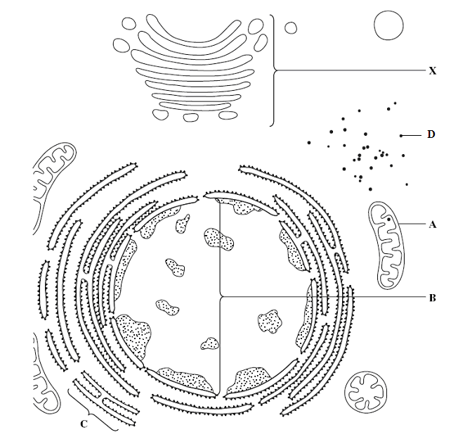

Fig. 1

 | (a) | Identify structures A – D.
 |  | A |  | C
 |  | B |  | D |  | [2]
 | (b)(i) | Identify and describe the function of structure X.
 |  |  |  |  |  |  | [3]
 | (ii) | Explain how X is adapted to perform its function.
 |  |  |  |  |  |  | [2]
 | (c) | Membranes of A, C and X all share the same basic structure.
 | (i) | Describe the basic structure of these membranes.
 |  |  |  |  |  |  | [2]
 | (ii) | Explain how the membranes differ in structure for A, C and X to perform different functions.
 |  |  |  |  |  |  | [2]
 |  | [Total: 11]

2 | Fig. 2 shows the stages of a eukaryotic cell cycle.  M phase  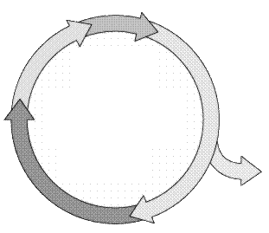  Cell cease to divide  G₁ phase  S phase  G₂ phase  Fig. 2
 | (a) | Briefly describe the events during the M phase.
 |  |  | [3]
 | (b) | Cell division is a highly regulated process. The cell passes a series of checkpoints before proceeding and completing mitosis.
 | (i) | On Fig. 2, label the cell cycle checkpoints. [1]
 | (ii) | Describe how the cell cycle is regulated at the checkpoints illustrated in (b)(i).
 |  |  | [3]
 | (c) | Explain why cancer is a multi-step process.
 |  |  | [3]
 |  | [Total: 10]

3 | (a) | Explain what is meant by a gene.
 |  |  | [1]
 | (b) | Red-green colour blindness is a sex-linked recessive trait. A woman with blood group A whose father is colour blind married a colour blind man with blood group O. The couple's first child is a normal vision boy with blood group O.
 | (i) | Illustrate the above results in a genetic cross.
 |  | [3]
 | (ii) | Calculate the probability of the couple having a colour blind daughter with blood group A. Show your working.  [1]
 | (iii) | Explain why it is more common for males to be colour blind.
 |  |  | [1]
 |  | [Total: 6]

4 | Fig. 4 shows the three stages involved in the polymerase chain reaction (PCR).  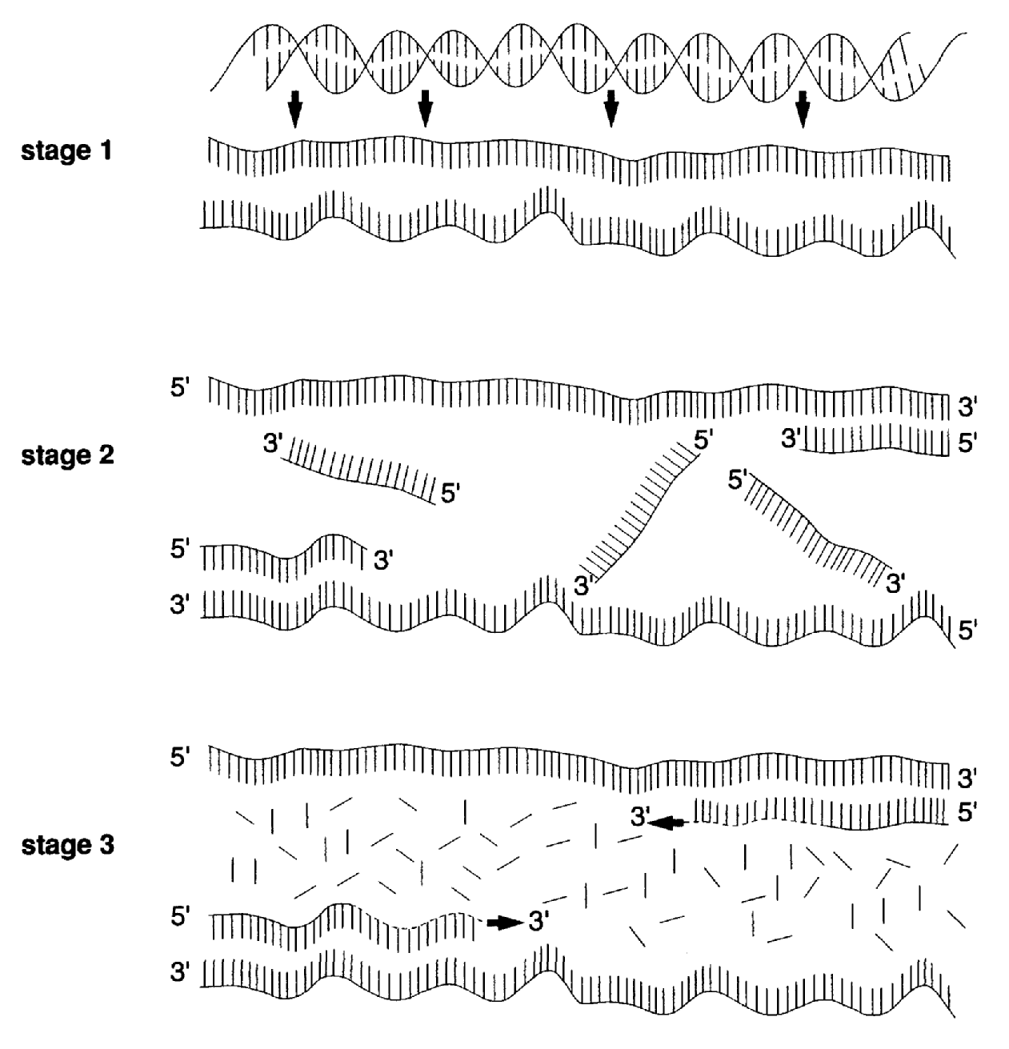  Fig. 4
 | (a) | With reference to Fig. 4, describe the events in stage 1 to 3.
 |  |  | [4]
 | (b) | Calculate the number of copies of the target sequence after 25 cycles of PCR. Show your working.  [1]
 | (c) | DNA polymerase, Taq polymerase, from thermophilic bacteria Thermophilus aquaticus is used in PCR. Explain why Taq polymerase is chosen rather than human DNA polymerase.
 |  |  | [2]
 | (d) | PCR is frequently used in genetic engineering. Describe how PCR can be used in the process of genetic engineering.
 |  |  | [2]
 | (e) | The PCR process sometimes results in the generation of both target and non-target sequences.
 | (i) | Explain why non-target sequences are sometimes produced in PCR.
 |  |  | [1]
 | (ii) | Describe how the products of PCR can be checked to ensure that the target sequence is synthesized.
 |  |  | [3]
 |  | [Total: 13]

Section B
Answer any one question.

Write your answers on the separate answer paper provided.
Your answers should be illustrated by large, clearly labelled diagrams, where appropriate.
Your answers must be in continuous prose, where appropriate.
Your answers must be set out in section (a), (b) etc., as indicated in the question.

5 | (a) | Describe the structure of DNA and its organisation in a eukaryotic chromosome. [6]
 | (b) | Describe how information on DNA is used to synthesise polypeptides in eukaryotes. [10]
 | (c) | Outline the roles of restriction enzymes in genetic engineering. [4]
 |  | [Total: 20]

6 | (a) | Describe how the Calvin cycle differs from the Krebs cycle. [7]
 | (b) | Explain the small yield of ATP under anaerobic conditions in both yeast and mammals. [8]
 | (c) | State the similarities between ATP production in mitochondria and chloroplasts and suggest why these similarities exist. [5]
 |  | [Total: 20]

